

## SAVITRIBAI PHULE PUNE UNIVERSITY

The Mini Project Based On

## COVID-19 Information Dynamic Website

**Submitted By:**

Ghanashyam Vasant Kadam

**Under Guidance of:**

Prof. D. A. Kamble. In partial fulfillment of

Laboratory Practice-IV (310258)



**DEPARTMENT OF COMPUTER ENGINEERING SAVITRIBAI PHULE PUNE UNIVERSITY 2024-25**

**CERTIFICATE**

This is to certify that the Mini Project based on,

## COVID-19 Information Dynamic Website

has been successfully completed by, Name: Ghanashyam Vasant Kadam Exam seat number:

Towards the partial fulfilment of the Final Year of Computer Engineering as awarded by the Savitribai Phule Pune University, at PDEA’s College of Engineering, Manjari Bk,” Hadapsar, Pune 412307, during the academic year 2024-25.

|  |  |
| --- | --- |
| Prof. D. A. Kamble | Dr. M. P. Borawake |
| **Guide Name** | **H.O.D** |

# Acknowledgement

My first and for most acknowledgment is to my supervisor and guide Prof.D.A.Kamble . During the long journey of this study, she supported me in every aspect. She was the one who helped and motivated me to proposer search in this field and inspired me with her enthusiasm on research, her experience, and her lively character.

I express true sense of gratitude to my guide Prof.D.A.Kamble . for her perfect valuable guidance, all the time support and encouragement that he gave me.

I would also like to thanks our head of department Dr. M. P. Borawake and Principal Dr. R. V. Patil and management inspiring me and providing all lab and other facilities, which made this mini project very convenient.

I thankful to all those who rendered their valuable help for successful completion on Internship presentation.

Name: Ghanashyam Vasant Kadam

# INDEX

|  |  |  |
| --- | --- | --- |
| Sr No. | Contents | Page No. |
| 1. | Abstract | 1 |
| 2. | Introduction | 2 |
| 3. | Objectives | 3 |
| 4. | System Specification | 4 |
| 5. | Methodology | 5 |
| 6. | Sample Code | 7 |
| 7. | Result / Output | 8 |
| 8. | Future Scope | 9 |
| 9. | Conclusion | 10 |
| 10. | Reference | 11 |

**Abstract**

This mini-project is centered on creating a dynamic web-based application aimed at delivering comprehensive COVID-19-related information to users. The application is designed to facilitate user engagement through features such as registration, login, and commenting on various updates. By employing a robust technological stack—including HTML, CSS, JavaScript, PHP, and MySQL— the platform aims to provide a seamless user experience while ensuring data security and integrity.

The primary objectives of the system include providing accurate and timely information about COVID-19, fostering community interaction, and maintaining a user-friendly interface. The development process will incorporate Regular Expressions for input validation in the registration and login forms, enhancing the application's security by preventing invalid data entries. This approach not only ensures that user credentials are handled safely but also promotes overall system reliability.

Once development is complete, rigorous testing will be conducted using tools like Selenium WebDriver and IDE. This testing phase is critical for identifying and rectifying any functional issues, ensuring that all features, including user registration, login capabilities, and commenting functionalities, perform as intended. By automating the testing process, the project aims to streamline quality assurance and enhance the application’s performance prior to its launch.

Looking ahead, the project has significant future scope for enhancement. Potential upgrades could include integrating real-time data feeds from health organizations to provide users with the latest statistics and guidelines. Additionally, features such as social sharing capabilities and an admin panel for content management could further enrich the user experience and expand the platform’s reach within the community.

# Introduction

The COVID-19 pandemic has fundamentally altered the way individuals seek and consume information about public health. As misinformation proliferates and the situation rapidly evolves, the demand for reliable, easily accessible data has never been more crucial. People across the globe are searching for updated statistics, guidelines, and safety measures to make informed decisions regarding their health and the health of their loved ones. In this context, a web-based platform that organizes and presents COVID-19-related information in a clear and interactive manner could serve as an invaluable resource for communities striving to stay informed.

This project is designed to address these pressing needs by creating a dedicated website that provides users with up-to-date COVID-19 statistics, including case counts, vaccination rates, and local safety measures. The platform will not only disseminate vital information but also facilitate user interaction through a commenting feature, enabling individuals to share insights, experiences, and questions. By fostering community engagement, the website aims to enhance public understanding and support collective efforts in combating the pandemic.

Data security is a paramount concern in any web application, especially when handling personal information. This project will utilize a MySQL database to securely store user data, implementing robust security measures to protect sensitive information. By prioritizing data integrity and user privacy, the platform will ensure that individuals feel confident in sharing their experiences and engaging with the content.

In addition to providing essential information and fostering interaction, the project emphasizes the importance of robust testing throughout the development process. Rigorous testing will be conducted to verify that the website functions smoothly, delivering a seamless user experience. This will include ensuring that all features—such as registration, login, and commenting—operate as intended, while also identifying and addressing any potential issues prior to launch.

Ultimately, this project seeks to create a comprehensive web-based platform that not only meets the immediate informational needs of users during the COVID-19 pandemic but also adapts to the evolving landscape of public health communication. By combining accurate data, user engagement, and strong security measures, the platform aims to empower individuals with the knowledge and support necessary to navigate these challenging times effectively.

# Objectives

Here are ten concise points with explanations for designing and developing a dynamic website for COVID-19 updates:

#### User Interface Design

Explanation: Create a visually appealing and intuitive interface using HTML and CSS that enhances user experience and ensures accessibility across various devices, making information easy to find and navigate.

#### User Registration and Login

Explanation: Implement a secure registration and login system that allows users to create accounts and authenticate themselves, providing a personalized experience while safeguarding their data.

#### Commenting Feature

Explanation: Develop an interactive comments section where registered users can share theirthoughts on updates, fostering community engagement and providing a platform for discussion and information sharing.

#### Data Management with MySQL

Explanation: Utilize a MySQL database to efficiently manage user accounts and comments, enabling CRUD (Create, Read, Update, Delete) operations to maintain data integrity and accessibility.

#### Form Validation

Explanation: Apply Regular Expressions for input validation in registration and login forms, ensuring that users submit valid data and enhancing the reliability of the information stored in the database.

#### Security Measures

Explanation: Implement strong security practices such as password hashing and secure session management to protect user credentials and personal data, thereby building user trust and ensuring privacy.

#### Testing Methodologies

Explanation: Employ various testing methods, including regression and exploratory testing, to identify bugs and ensure that all functionalities work as intended, maintaining a high-quality user experience.

#### Generating Test Reports

Explanation: Create comprehensive test reports that document the results of testing efforts, outlining any issues encountered and the overall performance of the application, which aids in quality assurance.

#### Evaluation of System Quality

Explanation: Define clear pass/fail criteria for each test case to objectively assess the functionality and reliability of the system, ensuring that it meets user requirements and performs effectively.

* 1. **Frontend**:

# System Specification

HTML, CSS, JavaScript o HTML: Structure of the web pages o CSS: Styling for a modern, responsive look

* + - JavaScript: Dynamic content, form validations, and interactive components
  1. **Backend**: PHP
     + Handles user authentication (login, registration) o Processes user input (comments)

# Methodology

### Step 1: Design the Website

The website will have multiple sections: a homepage with real-time COVID-19 updates, a user registration form, a login page, and a comment section.

* **Homepage**: Presents information such as daily cases, recoveries, and vaccinations.
* **Registration Page**: Users register by entering their name, email, password, and other details. The registration form will use Regular Expressions to validate user inputs.
* **Login Page**: Allows registered users to log in. Validates login credentials against the MySQL database.
* **Comment Section**: Logged-in users can post and view comments related to COVID-19 news.

### Step 2: Backend Development

Using PHP, the backend will interact with the MySQL database. This includes:

* Registering users
* Validating login details
* Handling comment submissions

### Step 3: Database Design

A MySQL database will be designed with tables for user accounts, comments, and news updates. The database schema will include:

* **Users table**: Stores user data (name, email, password)
* **Comments table**: Stores user comments and links them to specific users.

### Step 4: Testing with Regular Expressions

Form fields like name, email, and password will be tested using Regular Expressions to ensure:

* Email is correctly formatted
* Passwords are secure (e.g., at least 8 characters, contains uppercase, lowercase, and numbers)

### Step 5: Automated Testing

Selenium WebDriver and IDE will be used to automate the testing of key functionalities such as:

* Registration and login process
* Posting comments
* Display of COVID-19 updates

### Step 6: User Interface Enhancements

**Description**: After the initial development of the website, focus on enhancing the user interface to improve user experience and engagement. This step will involve:

* **Visual Design Improvements**: Use CSS frameworks like Bootstrap or Tailwind CSS to create a modern and responsive design. Ensure that the layout is intuitive, with clear navigation menus and visually appealing components that guide users through the platform.
* **Interactive Elements**: Integrate interactive features such as animated charts and graphs to display COVID-19 statistics dynamically. This could include real-time updates for daily cases, recoveries, and vaccination rates, providing users with visually engaging information.
* **Accessibility Features**: Implement accessibility best practices to ensure that the website is usable for all individuals, including those with disabilities. This may involve keyboard navigation support, appropriate color contrasts, and screen reader compatibility.

# Result / Output

* 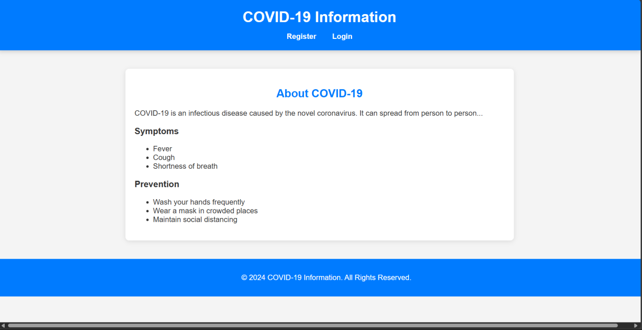**Dashboard:** In this section, the admin can see all detail in brief like the total, assigned and the sample collected and completed tests.

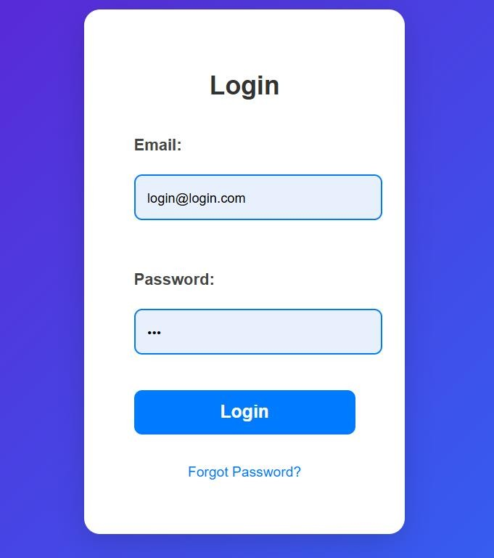

Here we can see that it is added successfully. In manage phlebotomist we can see all added phlebotomist.

# Future Scope

Here are five detailed points expanding on your suggestions for enhancing the COVID-19 updates website:

### Improved User Interface

The website's design can be improved by adopting modern UI/UX principles, focusing on intuitive navigation, clear typography, and visually appealing color schemes. Implementing user-friendly features such as dropdown menus, tooltips, and modals can enhance the overall experience. Providing users with a visually engaging and easy-to-navigate layout can encourage more interactionand help them find the information they need quickly.

### API Integration

Integrating external APIs can provide real-time COVID-19 statistics and updates from reliable sources, such as the World Health Organization (WHO) or local health departments. This integration will enable the website to automatically fetch and display the latest data on daily cases, recoveries, and vaccinations, ensuring users have access to the most current information without needing manual updates.

### Enhanced Security

To strengthen user account security, additional layers of protection, such as two-factor authentication (2FA), can be implemented. This requires users to provide a second form of verification (e.g., a code sent to their mobile device) when logging in, significantly reducing the riskof unauthorized access. Furthermore, implementing security measures like SSL encryption, regular security audits, and data encryption at rest can help protect user data from potential breaches.

### Mobile Compatibility

Ensuring that the website is fully responsive and optimized for mobile devices is essential, as many users access information through their smartphones. Using responsive design techniques, such as fluid grids and flexible images, will ensure that the website adapts seamlessly to various screen sizes. This optimization not only improves user experience on mobile devices but also enhances search engine rankings, as mobile-friendliness is a crucial factor for SEO.

### User Feedback Mechanism

Implementing a user feedback mechanism, such as surveys or suggestion forms, can provide valuable insights into user preferences and experiences. This feature allows users to share their thoughts on website functionality, content quality, and any areas for improvement. Gathering user feedback will facilitate continuous enhancements to the platform, ensuring it remains relevant and meets the evolving needs of its audience.

# Conclusion

This project successfully demonstrates the creation of a dynamic web-based application that provides COVID-19 information. Through the use of HTML, CSS, JavaScript, PHP, and MySQL, we developed a platform that allows users to register, log in, and interact with the content. Regular Expressions were used for validation, while Selenium WebDriver and IDE performed the automated testing. The system passed the defined test cases and demonstrated its functionality.

### Comprehensive Platform Development

The project effectively created a dynamic web-based application that consolidates essential COVID-

19 information in one accessible platform. By leveraging technologies such as HTML, CSS, JavaScript, PHP, and MySQL, the development team ensured that users could seamlessly navigate the site and access real-time data on COVID-19 statistics.

### User Registration and Interaction

The application enabled users to register and log in securely, fostering a personalized experience. Users can interact with the content through features such as commenting on updates, which enhances community engagement and allows for the sharing of valuable information among users.

### Robust Data Validation

Regular Expressions were effectively implemented for input validation during the registration and login processes, ensuring that user data is accurately captured and secure. This validation helps maintain data integrity and improves the overall reliability of the system by preventing invalid or malicious inputs.

### Automated Testing for Quality Assurance

The project employed Selenium WebDriver and IDE for automated testing, which allowed for thorough verification of the application’s functionalities, including registration, login, and comment posting. The successful completion of defined test cases highlighted the system’s robustness and readiness for user interaction.

# Reference

* **W3Schools** (HTML, CSS, JavaScript Tutorials)
* PHP Documentation (https://www.php.net)
* MySQL Documentation (https://dev.mysql.com)
* Selenium Documentation (https://www.selenium.dev)